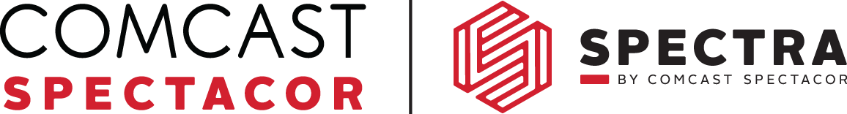
Budweiser events center NPO Program Application

Organization Information
NPO NAME
Address
City |  | State |  | Zip
Federal Tax ID
Attached completed IRS W-9 and IRS 501 C3 Letter with your application.
Statement of Group Purpose
(2-3 sentences)
Fundraising Goal for this partnership | $
Has your organization served food & beverages as a fundraiser before?
If Yes, please explain:
Has your organization partnered with Comcast and/or Spectra before?
If Yes, please explain:

Event & Event Commitment
Full Season (36 games) |  | Half Season (18 games) |  | On Call |  | Other (indicate #)
# of Adults (over 18) |  |  |  | # of Youth (16+)

Primary Contact – NPO Leader
First Name |  |  |  | Last Name
Address
City |  |  |  | State |  | Zip
Tel. Work |  | Fax |  | Home |  | Cell
Email

Secondary Contact – NPO Co-Leader
First Name |  |  |  | Last Name
Address
City |  |  |  | State |  | Zip
Tel. Work |  | Fax |  | Home |  | Cell
Email

Treasurer
First Name |  |  |  | Last Name
Address
City |  |  |  | State |  | Zip
Tel. Work |  | Fax |  | Home |  | Cell
Email

Checks Mailed To
First Name |  | Last Name
Address
City |  | State |  | Zip

I hereby certify that all information provided herein is true and complete to the best of my knowledge. I understand that this is an application only and does not constitute a binding agreement between my organization and Spectra.

Signature of Group Representative __________________________________________________ Date_________________

Name: _____________________________________________________________________________________________

